The Ultimate Hotel Room Cleaning Checklist: A Step-by-Step Guide for Housekeeping Staff
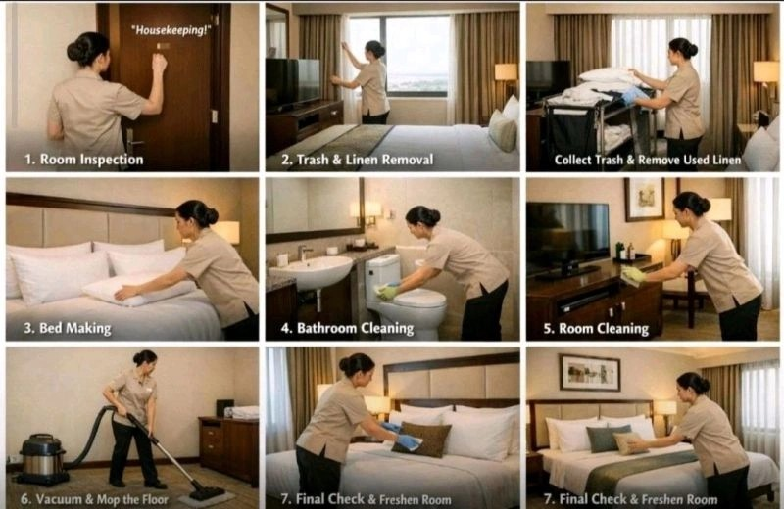
Ever wonder how top hotels maintain impeccable room standards day after day? The answer lies in a well-laid-out hotel room cleaning checklist that keeps housekeeping teams lined up and accountable.
Cleanliness leaves no middle ground. Guests notice it right away, and you either get it right or you don't. Delivering a flawless guest experience starts long before check-in. Every made bed, sparkling bathroom and thoughtful amenity adds up to the kind of stay guests can't wait to rave about.
A clear hotel housekeeping checklist turns daily cleaning into a consistent standard. It helps teams avoid missed details during quick room turnarounds. We'll walk you through a complete hotel cleaning checklist in this piece and cover every area of the guest room with step-by-step processes your staff can follow.

What is a Hotel Housekeeping Checklist and Why You Need One
A hotel housekeeping checklist is a detailed guide outlining the tasks required to prepare a guest accommodation for occupancy. It breaks down every cleaning step from bathroom sanitization to amenity restocking and creates a roadmap that staff follow shift after shift.

Will give consistency in all rooms
Standardization matters in an industry with high staff turnover. The definition of 'clean' varies based on individual staff members' personal standards, fatigue levels, or memory without a well-laid-out approach. A hotel cleaning checklist sets the standard for how work gets done and will give tasks that are completed to the highest standard. Guests who stay in March expect the same level of cleanliness as those who arrive in November. This consistency builds trust and will give the same high standard no matter which room guests book or who is on shift.

Improves training for new staff
A hotel room cleaning checklist that includes specific tasks and workflow steps helps train new hires faster. It gives them a clear workflow and a visible standard. New team members know what to do step by step, which helps them settle into their role with confidence. You can hand new staff the checklist instead of relying on shadowing alone, which serves as a training manual. They see the scope of work right away, which reduces the learning curve and will give standards they meet from day one. Regular workshops on cleaning techniques and safety protocols can boost performance by 15%.

Reduces guest complaints
Cleanliness ranks as the number one factor mentioned in negative reviews for hotels. A single hair in the bathroom or dusty surface can trigger scathing feedback. Hotel housekeeping checklists reduce complaints by catching small issues before guests notice them, especially in bathrooms and high-touch surfaces. They create a consistent experience in rooms and shifts, which reduces the risk of negative or inconsistent guest reviews. Guests walk into a space that feels sanitized and cared for when every room receives the same thorough attention.

Increases cleaning speed
Hotels using well-laid-out checklists cut room turnaround time by 20%. Teams move faster when tasks are defined and easy to follow. Mistakes decrease and quality stays high even during peak turnover. Staff can work more productively and tick off tasks as they go, which saves time and will give accountability. Supervisors can track who completed each task with ease and have a clear record of completed work.

Complete Hotel Room Cleaning Checklist by Area
A hotel room cleaning checklist broken down by specific areas helps staff work without missing critical spots. Each zone requires different attention levels and cleaning approaches.

Guest room and bedroom areas
Dust from the highest points and allow debris to settle downward for final floor cleaning. Remove all linens, rubbish and debris before you tackle surfaces. Wipe and sanitize doorknobs, handles, light switches and remote controls. Strip the bed and check the mattress for stains or damage. Remake it with fresh linens using tight hospital corners. Dust all furniture including headboards, nightstands and dressers. Clean mirrors and glass surfaces to a streak-free shine. Check drawers, under beds and closets to find items previous guests left behind. Hangers should be arranged in closets and ironing boards returned to storage. Empty trash bins and replace liners. Restock amenities like water bottles and tea. Verify all appliances work, including lightbulbs and alarm clocks. Vacuum carpets or mop hard floors with attention to edges and corners. Set room temperature and lighting to guest-ready levels.

Bathroom cleaning tasks
Remove all used towels, mats, rubbish and debris. Clean and sanitize surfaces including towel rails, cabinet handles and doors. Scrub tiles and grout lines to remove mold and mildew. Clean and sanitize toilets and bidets, including the bowl and seat. Polish mirrors and chrome fixtures. Check for water leaks from bathroom fixtures. Hair dryers should be clean and stored. Restock amenities including towels and toilet paper. Mop floors and verify exhaust fans work.

Kitchenette or coffee station
Clean and sanitize the coffee maker. Wipe down all kitchen appliances including microwaves and mini-fridges. Check refrigerators to find items previous guests left behind. Replace coffee pods, tea bags and sugar.

Entry and common spaces
Dust and sanitize all surfaces and electronics. Vacuum or mop floors and remove fingerprints from glass panels. Test lights and straighten furniture.

Step-by-Step Hotel Cleaning Process from Start to Finish
A systematic sequence takes the guesswork out of room cleaning. The process requires 25-35 minutes per room, depending on size and occupancy status.

1. Knock and enter the room
Knock three times and announce "Housekeeping" in a loud voice, then wait for a response. Never knock on rooms displaying Do Not Disturb signs. If no reply comes after waiting, knock again while entering slow. Keep the door open during cleaning for transparency and easy cart access.

2. Open windows and assess the room
Open windows where possible to allow air circulation and neutralize odors. Scan for maintenance issues, damage, or special cleaning requirements. Remove all trash from bins and gather any items guests left behind.

3. Strip and remake the bed
Strip beds and inspect mattresses for stains or damage. Remove sheets from corners, not sides, for smooth action. Replace with fresh linens using tight hospital corners. Arrange flat sheets with the headboard and ensure a wrinkle-free appearance.

4. Clean and sanitize the bathroom
Apply toilet bowl cleaner under the rim and allow it to work while cleaning other areas. Scrub with a toilet brush. Clean sink bowl, faucets and countertops, removing soap scum and water spots. Polish faucets for shine. Arrange amenities and restock soap, shampoo and towels.

5. Dust and wipe all surfaces
Start with highest surfaces and work downward. Dust bedside tables, desks, chairs, lamp shades and decorative items. Use microfiber cloths dampened a bit with multi-surface cleaner. Sanitize high-touch points including remotes, phones, handles and light switches using separate cloths for different areas.

6. Vacuum or mop floors
Vacuum and pay attention to corners, under furniture and high-traffic areas. Sweep or vacuum first, then mop with appropriate floor cleaner. Ensure floors dry to prevent slipping hazards.

7. Restock amenities and supplies
Replenish toiletries including shampoo, conditioner, body wash and lotion. Restock coffee pods, tea bags and sugar. Ensure bottled water and glassware are clean and arranged well.

8. Perform final inspection
Conduct a visual walkthrough and check all items are arranged without clutter. Test lights, television and HVAC systems. Verify room temperature is set right before marking the room clean.

Best Practices for Implementing Your Hotel Cleaning Checklist
Creating a hotel housekeeping checklist is only the beginning. Implementation determines whether it becomes a tool your team actually uses or just another document gathering dust.

Train staff on checklist usage
Clear, step-by-step instructions for every cleaning task should assume no prior knowledge. Training sessions need to cover how to perform each task and what standard of cleanliness is expected. Images demonstrate correct cleaning techniques, especially for complex tasks. Teams that speak multiple languages need checklists and training in their native languages to prevent misunderstandings. Checklists double as onboarding materials and make useful training resources for new hires.

Use digital tools to track progress
Modern hotels use housekeeping management software that integrates with their property management system. The system flags the room for cleaning and assigns it to an available attendant when a guest checks out. Staff update room status via mobile app and give the front desk up-to-the-minute visibility into which rooms are ready. Digital checklists allow photo documentation of issues and provide data for performance analysis.

Conduct regular quality inspections
Supervisors or managers need to inspect frequently to ensure hotel standards are met. Digital inspection apps enable up-to-the-minute reporting and task tracking.

Update checklists based on feedback
Housekeeping checklists should be reviewed every quarter and updated when standards, amenities, staffing levels or room configurations change. The housekeeping manager owns checklist standards and ensures they're followed.

Conclusion
You now have a complete hotel room cleaning checklist that covers every area your housekeeping team needs to maintain. Consistency and systematic processes make the difference between average and exceptional guest experiences. Implement this checklist with your staff first. Use digital tools to track progress and conduct regular inspections to maintain standards. Guests notice the details, and a well-executed cleaning protocol keeps them coming back. Your reputation depends on it.

